

**Schedule Robot**

Project Completion Date: December 10th, 2019

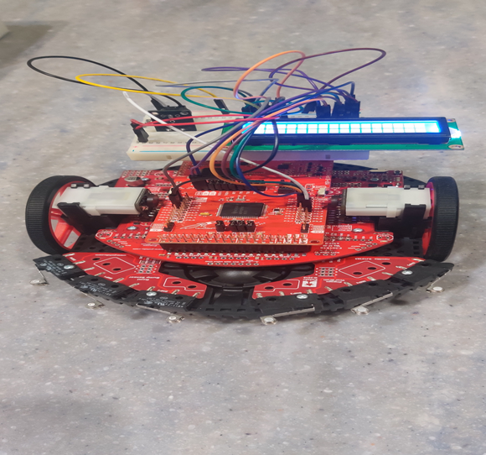

Armando’s Entourage

Rhea Baweja

Fan Han Hoon

Shannon Ross

Mahek Shah

EDSGN 100, 1st Semester, 2019, Section 14, Elizabeth Starkey

Report Date: December 16th, 2019

***Executive Summary***

Through the analysis of interviews, the team identified a problem that a typical college student faces. With the team’s and interviewees’ experiences, the issue was defined as a college student who is unable to manage his/her time efficiently. College students have a lot of things to do and not enough time to conduct all tasks such as going to classes, exercising, and maintaining extracurriculars and jobs.

Taking the customer’s needs and problem into consideration, the team’s main objective is to design a robot to aid college students in managing their time more efficiently by making a schedule for him/her and give reminders for their daily tasks. This robot would be simple, cheap, time efficient and durable as a college student would need something to be. The design consists of a robot that makes a schedule set by the user for each day and accordingly reminds the user of the tasks that need to be conducted at different times during the day. This reminder would act as an alarm clock and buzz every time the user is reminded about tasks. The team created a robot that consisted of a timer, in seconds, which could be set by the user.The robot proved to be durable and cheap, but was not simple or efficient. More advanced materials and technology would be required in order to have the robot be more efficient and simple for the user.

**Table of Contents**

1.0 Problem Definition 3

1.1 Problem Statement 3

1.2 Systems Diagram of Base Scenario 4

1.3 Market Exploration 5

1.4 End-User Information. 8

1.5 Design Requirements 10

2.0 Concept Generation and Refinement 11

3.0 Concept Selection 14

4.0 Prototyping and Modelling 15

5.0 Evaluation of Design 20

5.1 Economic Analysis 22

5.2 Life-cycle Assessment 23

5.3 Market Feasibility Analysis 23

6.0 Conclusions and Recommendations 24

References 25

Appendix: (listed in sections A, B, C) 26

**1.0 Problem Definition**

Currently, college students are all facing a similar dilemma: time management. Many students often feel there is not enough time in the day to complete everything necessary. Juggling course work, classes, extra curriculars, jobs, and exercise can seem impossible, but it leaves little time for sleep, down time, and consideration for mental or physical health. With today’s implementation of technology people are easily distracted by social media, games, and streaming decreasing productivity. Due to this, students end up wasting an immense amount of time talking to friends, playing games, and watching videos/shows.

Despite using planners and different online calendars, students hardly ever stick to schedules they have planned out. First year students are even less likely to stick to their schedules since they have no one reminding them to complete tasks during this transition to college life. College students need a way to stay on track with what they have planned out in order to remain productive and use their time efficiently. This would allow them to have time to remain healthier and happier among all the stress from school.

**1.1 Problem Statement**

Many students often feel there is not enough time in the day to get everything necessary done. The team’s goal is to create a robot that helps college students to use their time more productively, giving them more time to be physically and mentally healthy.

## 

**1.2 Systems Diagram of Base Scenario**

In order to better understand how the TI robot functions with its inputs and outputs, a systems diagram was created. The inputs used in this design were determined to be the power button, the side buttons next to the motors, pressing both the side buttons and the timer completing. These inputs could then be programmed to affect the outputs. The outputs were determined to be the turning on/off the LCD display and robot, increasing/decreasing the time, starting the timer, and playing the buzzer and making the robot move.

Figure 1: Systems Diagram of TI Robot



## 

## **1.3 Market Exploration**

The team conducted market research to see which robots are already in the market and which ones are emerging in the market or currently being developed. To conduct this market research, each member answered a few questions which would provide the group with information about the robot such as the cost, the market segment and its characteristics.

Table 1. Representation of Existing Robots in the Market

|  | **New** | **Emerging** | **Mature** |
| --- | --- | --- | --- |
| **Dull** | M-Blocks | Humanoid Artificial Intelligence Resturant Robot Waiter |  |
| **Dirty** | Robo-C |  | Electrolux Tribolite |
| **Dangerous** |  | CRS-(I)  Common Robotic System Individual | AI Military Robot BigDog |

Included below are two robots found while conducting the market research that is most applicable to the customer needs. Both the waiter robot and the M-Blocks complete dull tasks. They could potentially be utilized as time savers for the users.

Figure 2: Diagram of the Humanoid Artificial Intelligence Restaurant Robot Waiter

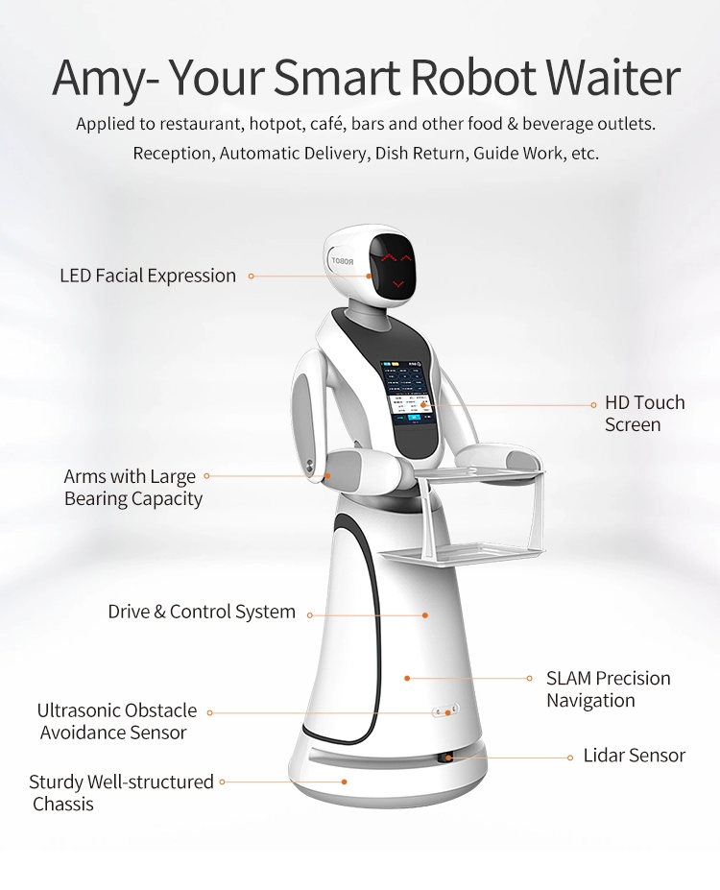

The Humanoid Artificial Intelligence Restaurant Robot Waiter is applied to the F&B industry where it does reception, automatic delivery, dish return and guide works. The robot was invented by a chinese company where they intended to replace the traditional human workforce where robots can have a better cost-productivity ratio in the long-run as they will not suffer from fatigue and be able to run 24/7 non stop. On top of that, it also runs delivery tasks that are dull and dirty where it has perfectly addressed the issue of shortages of people who are willing to do those jobs. The AI robot waiter is still under an emerging market where it can still have a lot of improvements especially on the base cost.

Figure 3: M-Blocks moving across each other

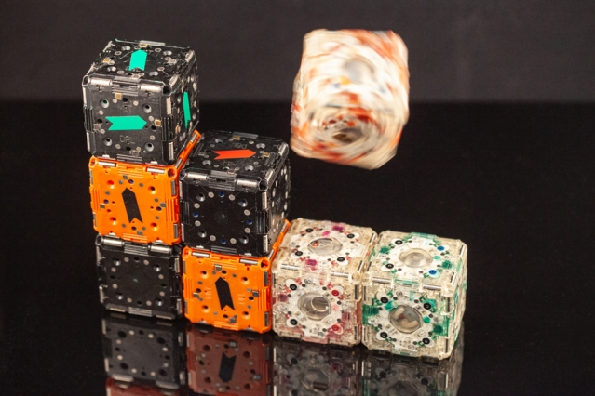

These cubes assemble themselves and can move around based on programs. They can find each other and cluster together or follow a light source. These blocks are currently a new technology that will potentially be used in the medical and manufacturing fields in the future. They are made using braking internal flywheel and sensors the detect barcode like features on other blocks. They are magnetic so they can stick to each other. The blocks at the moment are difficult to manipulate and move relatively slow.

All of the robots researched above assist humans with tasks that are dull or difficult to perform. The most interesting ones were the M-Blocks, BigDog, Robo-C, and the waiter robot. Some of the mechanisms used for these robots to move around could be utilized in a robot made to assist in time management. All of these robots have the potential to reduce the time college students need to do tasks throughout the day. Technology similar to BigDog could be used to carry things like groceries from place to place. The M-Blocks could be used to clean or put items away. A robot similar to the waiter robot or Robot-C could be utilized to help college students with boring tasks such as writing emails, washing dishes, or delivering food to the user.

**1.4 End-User Information**

Interviews were conducted in order to determine what tasks people would like a robot to perform for them and see their overall perception on the use of robots today. These interviews helped the group identify customer needs. Members of the team went out and asked about six people around the Penn State campus if they would be willing to be interviewed for this design project. Once they agreed to being interviewed the interviewees were asked a couple of questions and their responses were documented. The questions were:

* What would you like to have a robot to do for you? Why? Is it because it's a task you wouldn’t want to do yourself ? Easy or hard?
* What scares or excites you about robots? Why?
* How independent would you want a robot to be? Can we have an example of what that might look like?
  + The different levels of automation were discussed when asking this question
* In what area do you think robots would be the most useful? Why?
* Where would you want to have a robot implemented in your life?

The team then came together and discussed the interviews that had the most insight on what people may want a robot to do for them and why they would want a robot to complete this task for them. Four interviews were looked at more in depth and analyzed as a group.

Table 2. Description of person interviewed and important response to interview questions.

| **Person Interviewed** | **Their Response** |
| --- | --- |
| An 18 year old IST undergraduate student at PSU | * A robot would be useful in a household setting or in the healthcare industry * A personal assistant would be beneficial |
| An 18 year old undergraduate student at PSU | * Could be useful in automated cars or doing menial tasks * Believes they should be fully automated with a failsafe * Worried humans will become reliant on robots and incapable of doing anything on their own |
| A member of the PSU engineering teaching faculty, also a mother | * Most useful in chores * A robot should be fairly independent, but should run on a schedule created specifically by the user that can be changed at any time * Only does what it’s programmed to do, does not learn on its own * Is scared of the potential of no need for human interaction in the future |
| A nineteen undergraduate pre-med student at psu | * A robot would be useful doing “annoying” tasks   + Ex: Texting back, emails, signing up for things, etc * Is scared of robots doing tasks without being told/ programmed to do * Was struggling with physics at the time of the interview and suggested a tutor robot would be helpful and save a lot of time |

These interviews were then compiled into one persona. The persona was defined in order to have a better understanding of the problem and the target consumer. The persona developed for this design is an undergraduate college student. The persona does not have time to complete everything they want to do as they have to focus mainly on school work, therefore, they need a robot assistant to help them completing minuscule/time-consuming daily tasks so they can focus on other more important things. They do not have time to live a healthy lifestyle because of their limited time to eat, sleep, be active, and destress.

## 

## **1.5 Design Requirements**

## These customer needs were generated through the persona described above. Since the design is a college student, it is important that the design is low cost and durable to fit into a small budget. This became the most heavily weighted customer need (40%) later in the design process. Durability was weighted at 25% because it ties into the idea of the robot being low cost. The design needs to be simple enough that anyone can use it so it was given a weight of 20%. This particular robot is specifically being designed to be a time saver, so that customer need was only weighted at 10% because all designs created should already be efficient. Aesthetics are important when creating a product, but less important than the other ideas previously stated so it was given a weight of 5%.

Table 3. Description of engineering specifications associated with customer needs.

| **Customer Needs** | **Weights** | **Specifications** |
| --- | --- | --- |
| Low Cost | 40% | The cost should be less than $300 |
| Simple | 20% | Easy for any college student to use and should not take an excessive amount of time to learn how to use |
| Time Saving/ Efficient | 10% | Save the user time throughout their day and allow them to be more productive |
| Durable | 25% | Able to last for at least 4 years |

**2.0 Concept Generation and Refinement**

The team used concept generation methods to come up with an innovative solution. The idea generation method the group used is a C-sketch (Collaborative Sketching). This method required each team member to come up with individual possible design solutions. Each member drew different designs for multiple solutions and then shared the ideas with the rest of the team. Every person explained their design and asked for inputs to modify the design, either add, delete or change something. After sharing the designs and making changes, the team came up with one final design which included features from all the individual designs. Attached below are a few of the independent designs with descriptions underneath them.

Figure 4: C-Sketch Examples

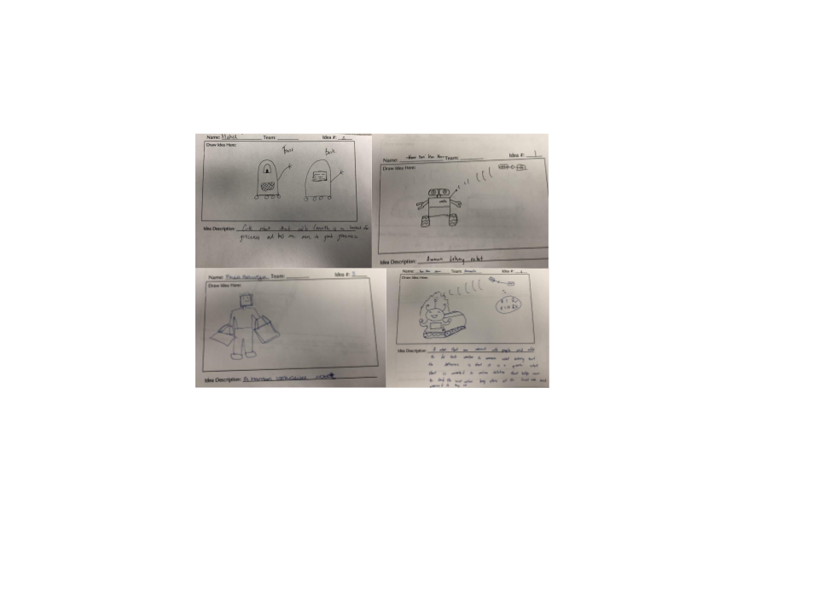

Figure 5: Low Fidelity Prototypes

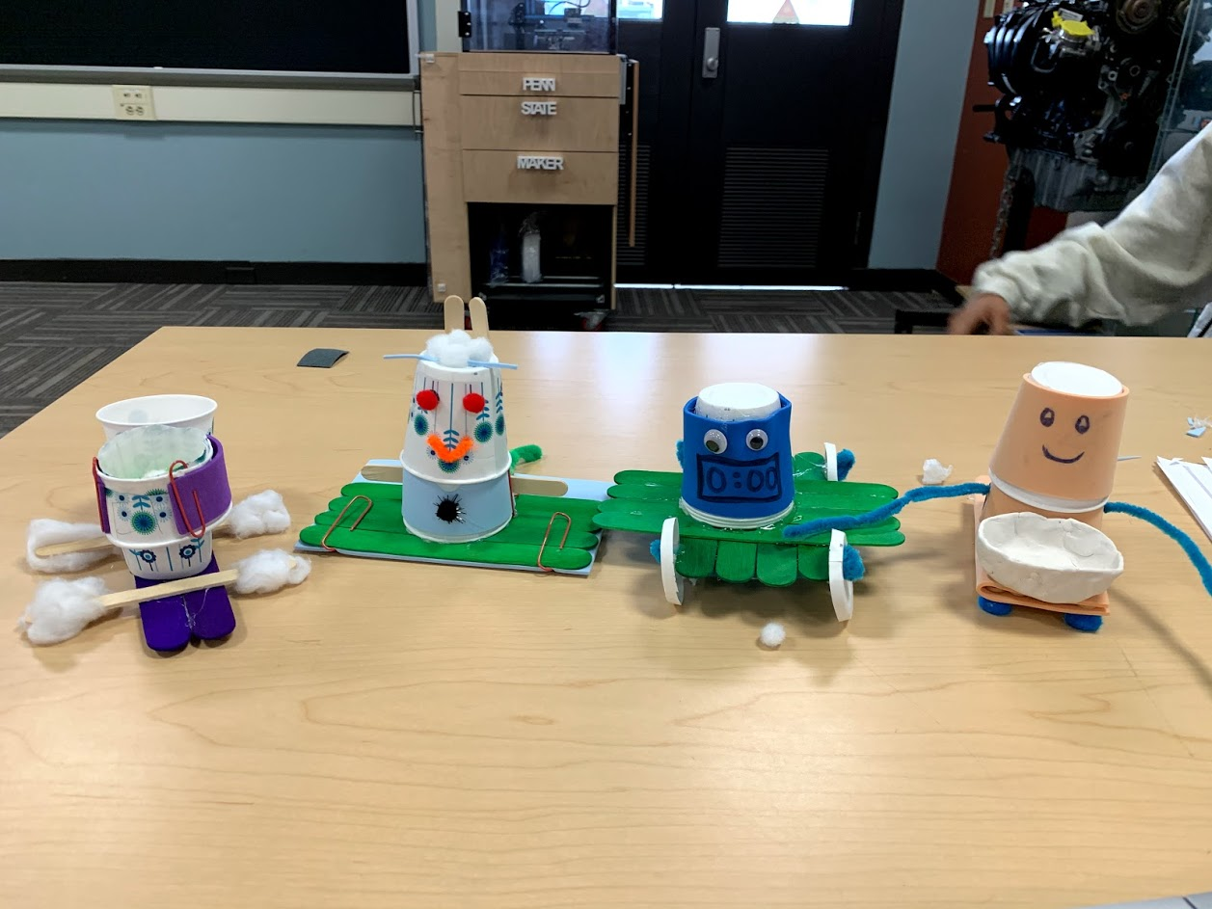

All of the low fidelity prototypes designed are pictured above. The descriptions are listed below in order from left to right.

Prototype #1: Health Bot

One robot prototype was designed to help the user take proper care of their health. The user would be a college student with a busy life and is unable to maintain his health due to the workload. Therefore, the team member designed a robot to help a student take better care of his/her health. Some of the functions this robot would be able to perform are to remind the student to take his/her medicine on time daily, measures their calorie intake, counts their sleeping hours and blood pressure. The robot would go to the medicine dispenser at the end of every day/meal and refill the cup it has and according to the time set by the user, remind the user to take medicine. The robot would then navigate the user by a mechanism where the robot knows the design of the house and follow the user by a tracker. The robot would also have a voice box inserted where it would call the user to remind them to take medicines.

Prototype #2: Tutor Bot

This robot prototype was designed to have the aspect of deep learning where it works something similar to the “Jarvis” in Iron Man but have the purpose of supporting students academically. With the connection to the internet, it will be able to learn all the academic knowledge for various subjects and analyze the suitable material for the user to refer to. The initial concept of the robot has a rough dimension of a 500 ml water bottle. The parts that make up the eye of the robots are actually a camera and hologram projector. Whenever the user has any troubles on revising or working on their assignments, they can either use voice command (“commands similar to Siri”) or take the robot and scan the questions such as math question where the robot will start to analyze the problem and projects a hologram that shows detailed workings or explanation.

Prototype 3: Schedule Bot

This robot prototype was designed to help people be more efficient with their time. The user would take their schedules or daily tasks and upload them into this robot. The robot would then take the tasks and schedules and set up reminders throughout the day on when the person should switch to the next task. The robot would be about the size of a half sheet of paper and be able to follow the user around as they move around their house. Each ‘alarm’ could be customizable based on what the user wanted it to be (a specific sound, song or voice). Along with the alarm, lights would gently flash to draw attention to the schedule bot. A clock would be on the schedule bot’s face so the user would not need to check their phone while working on a task. This would help the user be more productive with their time.

Prototype #4: Grocery Bot

Working adults and college students who are busy with their lives and don't have enough time to go grocery shopping every week to buy cheap products in bulk to save money as well. This robot would determine where the cheapest groceries are from a list. It would then be able to use a GPS system to go out and purchase the groceries from the different stores and bring them home. This would save the user both time and money.

**3.0 Concept Selection**

Using the weights discussed previously, the designs were compared. The schedule bot had the highest score, so it is the design that moved forward. Aspects of the health bot will be implemented with the schedule bot since they have similar concepts. The schedule bot will also have programmable health reminders to tie the two together

Table 4. Concept Selection

|  | **Concepts/Solutions** | | | | | | | | |
| --- | --- | --- | --- | --- | --- | --- | --- | --- | --- |
|  |  | **Grocery Bot** | | **Schedule Bot** | | **Health Bot** | | **Tutor Bot** | |
| **Criteria** | **Weight** | **Rating** | **Weighted Score** | **Rating** | **Weighted Score** | **Rating** | **Weighted Score** | **Rating** | **Weighted Score** |
| **Low Cost<$300** | **40%** | 2 | 0.8 | 4 | 1.6 | 2 | 0.8 | 1 | 0.4 |
| **Time Saving/**  **Efficient** | **10%** | 5 | 0.5 | 3 | 0.3 | 4 | 0.4 | 5 | 0.5 |
| **Simple** | **20%** | 2 | 0.4 | 5 | 1 | 3 | 0.6 | 1 | 0.2 |
| **Aesthetically Pleasing** | **5%** | 4 | 0.2 | 3 | 0.15 | 4 | 0.2 | 3 | 0.15 |
| **Durable > 3 years** | **25%** | 1 | 0.25 | 4 | 1 | 2 | 0.5 | 2 | 0.5 |
| **Total** | **100%** |  | **2.15** |  | **4.05** |  | **2.5** |  | **1.75** |
| **Rank** |  |  | **3** |  | **1** |  | **2** |  | **4** |
| **Continue?** |  |  | **No** |  | **Yes** |  | **Yes** |  | **No** |

.

**4.0 Prototyping and Modeling**

The team’s selected concept is the schedule bot as it was found to be the most suitable and wanted by the persona. The schedule bot will have concepts similar to that of the health bot. Each team member made a low fidelity prototype using paper, cardboard, and other low cost materials. They were replicas of what the team would want the final robot to look like and what functions it would conduct.

Figure 6. Low Fidelity Prototype of the Schedule Bot

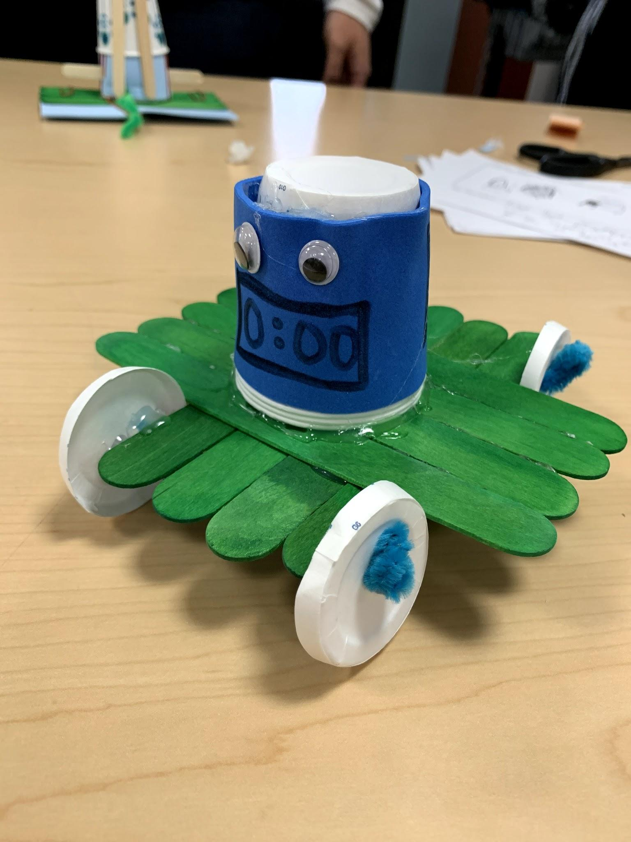

The user interacts with the prototype by inputting their schedule for what their daily week would look like. An alarm would then buzz to remind them of the tasks they have to do prior to the time. For example, if the user has a meeting at 2:00 p.m, then the robot would

The functions of the TI robot were used in the final prototype. The side buttons, power button, and pressing both side buttons, and the timer finishing were the inputs utilized. The outputs used were turning on/off the LCD and robot, increasing/decreasing time, starting the timer, playing the buzzer, and making the robot move. The buzzer and display were added onto the robot individually, as they would be part of the final product.

Figure 7. Systems Diagram for Final Schedule Bot Prototype



The team’s robotic system falls in the emerging market segment as there are already some models of this design present in the current market. However, the market has not been fully explored by companies, nor does the market have many products existing. The technology for robots such as this does not entirely exist yet, hence the market is emerging. This robot conducts dull work, in a more applicable manner, making it more durable and useful. The robot is not completing tasks for the user, but instead reminding the user of all the things they have to do. It would also be very easy to maintain and use making it ideal for a college student, as it would not have to be replaced or repaired often.

Figure 8: Concept of Operations



The figure above (Figure 8), represents the concept of operations for the robot. The team concluded that for testing purposes and feasibility, the functional prototype should be regarding the alarm and movement of the robot. An ideal way to test both of these factors was to turn the robot into a moving alarm. For future purposes, the team would have wanted to create an app and gps tracking system for the robot to physically be able to move to the user and receive input from the user’s phone. However, because of time and technological constraints, the team created a robot that would have the ability for the user to set a time, and the robot would move when the timer was completed.

Starting with the low fidelity prototype in Figure 6, the group decided that the robot needed to have a display which showed the time remaining on their timer. Additionally, the group decided that the robot should have a buzzer which sounds once the timer is complete so that the user knows their timer is finished. Knowing this, the team found an Arduino buzzer and HiLetGo LCD display that could be used to connect to the robot. After this was completed, the group had to actually connect both items to the robot and ensure they are working. To do so, the group used a Youtube tutorial, by Films By Kris Hardware, called “Arduino LCD Display Wire Hook Up Backlight LCD 1602 Module.” Once, the team was able to work the LCD display, hooking up the buzzer to the robot was not as difficult, as the group knew what wires were used for what function.

After both items were connected to the robot, the group then had to code the actual functions for the robot. Because none of the members were experts in coding, it took several class periods (as well as time outside of class) for the group to create a fully functioning timer. The code consists of using the two buttons on the side of the robot (PUSH1 and PUSH2 as shown Figure 9 below). These two buttons would either increase or decrease the time (when pushed individually) or they would start the timer (when pressed at the same time). When the LCD display reads “Set Time: 0,” then the user can press the buttons to set their time in seconds. Once they are finished setting their time, then the timer will run until it is complete. When the timer completes, the buzzer is set to play a sound for half a second, which indicates the timer is complete. Additionally, when the timer finishes, the robot will begin to move and stop until the bump switches have been hit four times. After the bump switches are hit four times and the robot stops moving, it will reset and read “Set Time: 0,” indicating that the user will be able to start another timer.

Figure 9: Pin map provided with the TI Robot

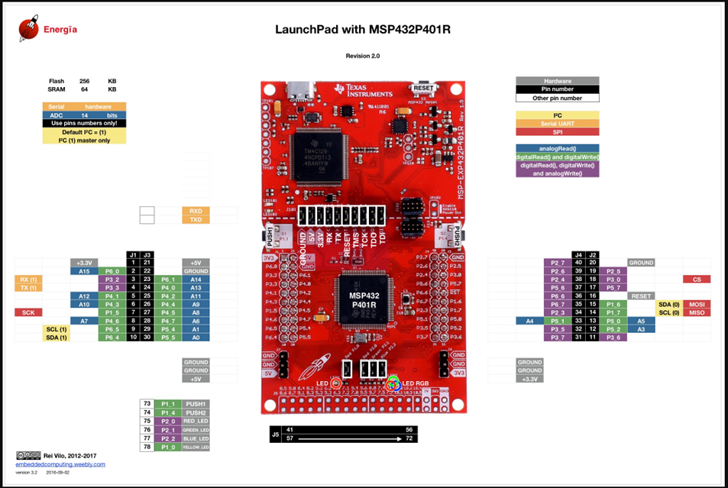

Figure 10: An image of a portion of the code used for the robot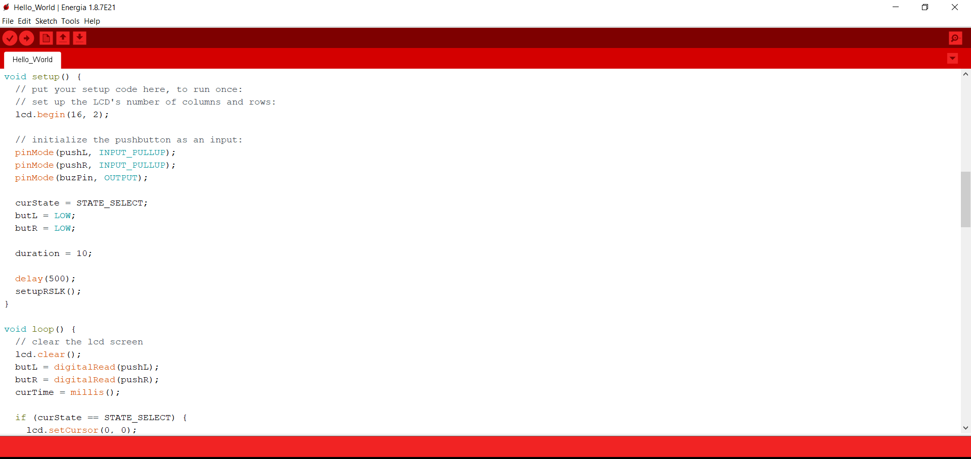

Figure 10 is a representation of a portion of the code that the team used to implement a timer into the robot. This shows how each of the functions were setup to work at specific times while the robot was completing its task.

If this robot were to be deployed it would be crafted to be more user-friendly and likable. The robot would have a friendly face as shown in the low fidelity prototype (Figure 6). It would also have the ability to set a timer in hours, minutes, and seconds so that the user does not have to convert their time into seconds every time. Additionally, the robot should be able to connect to an app on the user’s phone, because this would make it easier for the user to set their schedule and timers. The most ideal aspect of having this robot would be that the student will not have to look at their phone to see what their next task is. Through the team’s research, it was found that phones are a large distraction in the everyday life of students. Hence, having this robot would allow for students to focus on their tasks completely and leave their phones behind.

The manufacturing and assembling of this product would be done in the U.S, and it would not be as costly as other robots. The basic TI Robot that the team used has a value of about $150, and the extra wires, lcd display, buzzer, and components for the face of the robot would cost approximately $50 in total. Hence, the robot would cost a total of $200 to create, which means it could possibly be sold for under $300. In addition to this, universities and colleges may have an interest in purchasing these robots for their students to checkout from libraries or rent. It is possible that these robots could be sold in bulk, which could be more beneficial than targeting a college student as the prime buyer of this robot. A college student can be the prime user, however it is not necessary that they be the prime buyer as well.

# **5.0 Evaluation of Design**

# It took a long time to attach the display to the robot and get the code to run the timer to be functional. This did not leave a lot of time for testing. The robot was mostly tested by seeing whether or not the code ran the way it was supposed to without having to turn the robot on and off each time the timer was set. Since this prototype could not have a person's schedule uploaded in order to set the timer, the simplicity was tested based on how easy it was to reset the timer. The cost was tested by calculating an estimated price based on the current prices of parts in the market.

Table 5. Testing of design against requirements, including evaluation methods and results

| Design Requirement | Evaluation Method | Pass/Fail Criteria | Result? | Reasoning |
| --- | --- | --- | --- | --- |
| Cost | Calculate materials costs for a single unit/system | Must be less than $300 | Pass | When looking at different parts and sensors using different sources, the price is estimated to be $200 (Refer to Appendix B) |
| Simple | Setting and starting the timer | Easy ways to start timer and learn how to use | Fail | The robot can only set a timer in seconds. A typical task for a college student can take anywhere from thirty minutes to several hours, making the design inefficient |
| Efficient | Running the code multiple times and using different timer settings | Does the robot run the code the way it’s designed to without any human input | Fail | The robot currently doesn’t function at the capacity desired and the user must reset the timer after every task |

Overall, this prototype is a good start towards the final product, but it did not meet all the desired requirements. The schedule bot was essentially a glorified timer that only ran in seconds. Yes, it did work when the timer was set. It bumped into the user while the alarm went off to remind the user to switch tasks. It did not, however, have the capability to have the user’s schedule uploaded to it or preset. The user would need to reset the timer manually each time which was the goal when creating the schedule bot. The timer also only ran in seconds which could be very inconvenient when setting the timer for an extended period.

In the future, a timer that included seconds, minutes, and hours would replace the timer that only runs in seconds. Eventually the schedule bot could be either wifi or bluetooth enabled, so an app could be used to upload a preset schedule. The scheduled bot would then simply run off the schedule the user puts into it without having to reset the timer for each task. There could also be a different buzzer added, so the user can customize what the alarm sounds like for each task. A function similar to a GPS system would also be added, so the schedule bot could follow the user around their living space. This would allow for the user to only have to interact with the schedule bot when the alarm goes off, and not go find the robot once the timer has completed.

## **5.1 Economic Analysis**

Below is a table describing some of the basic expenses it would take to build a small factory and keep it running. There would be an outright cost of $10,000-$45,000 to build the small factory, assuming all the manufacturing equipment would be included. If the factory were to run eight hours a day, each worker would produce four robots a day, and ten workers were hired, then the total cost for one day would be $8,740.32. This means it would cost $218.51 to produce one schedule bot. If consumers were charged $250.00/robot the company would make a profit of $31.49/robot.

Based off of this model, if $10 was taken out of the profit to pay the outright cost, it would take about 1,000-4,500 robots to cover it. That would mean it would take about 25-113 days to cover the cost of building the small factory. If the factory only produces seven days a week, it would take 4-16 weeks to cover the $10,000-$45,000. Based off of these calculations, the schedule bot appears to be economically feasible, but there are a lot of other unknown variable expenses that go into a manufacturing facility.

Table 6. Manufacturing Costs

| **Fixed Cost** | **Monetary Value** | **Variable Cost** | **Monetary Value** |
| --- | --- | --- | --- |
| Small Factory | $10,00-$45,000 | Wages | $8/hr. |
| Electricity Billing  (95.1 kWh) | $12.54/hr. | Materials Cost | $200/robot |

## 

## **5.2 Life-cycle Assessment**

## When looking at Carnegie Mellon’s Economic Input-Output Life Assessment (EIO-LCA), the amount of energy needed to produce a product similar to the schedule bot in different countries was compared. An estimate of the energy needed to produce in the United States was compared to an estimate of energy needed to produce in China. In total, it would take 4.44 TJ of energy to produce in the US versus 39.0 TJ in China (Appendix C). The electronic equipment industries were compared along with the watches, clocks, and other measuring/ controlling devices sector (US) versus the electronic device and element sector (China). It would be more energy efficient to produce the schedule bot in the United States based off of these numbers. The target consumer for this product lives in the United States, so it makes sense to produce it here in order to cut down on the energy, greenhouse gases, and pollutants needed/created during transportation.

Overall, if the schedule bot has a charging port to recharge its batteries, this product should last throughout the average time it takes for a college student to get their degree. The schedule bot was made to be used in a dorm room or an apartment, so it would not have to face the elements. Having a durable outer shell would keep the electronic components in place.

Once the schedule bot has outlived its usefulness, some of its components can be recycled. Similarly to a computer, many of the inner workings and wires could be reused. Other components could be melted down and recycled. Some of it may need to be thrown out and put into a landfill, but most of it could be reused or recycled.

## **5.3 Market Feasibility Analysis**

There is a potential substitute good that could decrease the demand for this product despite it having the potential to do well in the market. Most of the time college students will simply use their phones with calendar apps and timers to remind themselves when to complete tasks. This could cause the schedule bot to be less desirable. While phones can be useful occasionally, they can also decrease productivity. College students often get distracted by social media and games when checking their phone timers or calendars. That is why the schedule bot has the potential to be effective in the market. It eliminates the need to constantly check a phone for new tasks or to turn off a timer, decreasing the probability of the user getting distracted, increasing productivity.

# 

# **6.0 Conclusions and Recommendations**

Across the United States countless college students are struggling to balance all the demands of course work along with extracurriculars and personal well being. Many college students do not get the recommended hours of sleep, eat well, and are often sick. Often times school work is put before their own health. It can be hard to manage their time to effectively get done all that needs to get done in one day. The team’s goal was to create a robot that allows the user to have more time during the day to take care of themselves.

Through interviews conducted at The Pennsylvania State University, a list of customer needs for a solution was generated. The solution needed to be durable, low cost, simple, and efficient. The team brainstormed different possible solutions using the c-sketch technique. Four low fidelity prototypes were created using some of the solutions brainstormed. Using a weighted concept selection chart, it was determined that the schedule bot would be the solution to move forward.

The schedule bot was further prototyped and tested. The schedule bot proved to be affordable and durable, but was not simple or efficient. The prototype schedule bot could only run a timer in seconds and had to be reset after each task was completed. It also could only remain in one location, meaning the user would need to carry it with them throughout their living space.

In the future, before the schedule bot reached the market, a new timer would need to be implemented in the design. A system similar to a GPS would also need to be added in order for the schedule bot to follow the user as they move around their living space. The robot could also be wifi or bluetooth enable to allow the user to upload their premade schedule. This solution has the potential to save college students time by reminding them of how much time they should be spending on one task, but changes would need to be made to the design and more testing would need to be done.

**References**

1. Carnegie Mellon University Green Design Institute. (2019) Economic Input-Output Life CycleAssessment (EIO-LCA) US 2002 (428 sectors) Producer model [Internet], Available from:<http://www.eiolca.net/> [Accessed 14 Dec, 2019]
2. “Electricity Rate by State.”*Electric Choice*, Jan. 2019, https://www.electricchoice.com/electricity-prices-by-state/
3. “How Much Does It Cost To Build A Factory?” *Central Steel Build*, 22 Aug. 2019, https://www.centralbuild.com.au/much-cost-build-factory/
4. Lee, Bonnie. “How Much Does it Cost to Create Your Product?” *FoxBusiness*, Fox, 23 Mar. 2019, https://www.foxbusiness.com/features/how-much-does-it-cost-to- create-your-product
5. “Manufacturing Facilities.” *Business Energy Advisor*, OUC, 1 Jun. 2017, https://ouc.bizenergyadvisor.com/article/manufacturing-facilities
6. “Robo-C.” *Promobot*, 2019, promo-bot.ai/production/robo-c/.
7. “Robot Waiter: The Amy Waitress is the Ideal Marketing Tool.” *Service Robots*, https://www.servicerobots.com/amy-waitress/
8. Staff, The Robot Report. “Self-Transforming M-Blocks Jump, Spin, Flip, Identify Each Other.”*The Robot Report*, MIT News , 31 Oct. 2019, www.therobotreport.com/self-transforming-m-blocks-jump-spin-flip/.
9. “TIRSLK-EVM.” *TI*, www.ti.com/store/ti/en/p/product/?p=TIRSLK-EVM.

# 

# **Appendix: (listed in sections A, B, C, D...)**

**Appendix A:**

Solutions generated throughout the design process and why they did not move forward to be prototyped.

Table 7. Additional Ideas Generated

| **Solution** | **Description** |
| --- | --- |
| Grocery Robot | A robot that could search prices of goods at different stores, go and purchase the goods for the user, and bring them back to their residence. |
| Delivery Robot | A robot that can go and pick up items the user purchased and deliver them to their residence. |
| Human Look Alike | A robot that looks like a human and can perform similar functions to a human. It would be able to help around the house with things like chores (doing dishes, laundry, etc.) |

**Appendix B:**

Estimated total cost of material needed to create one schedule bot.

Table 8. Costs

| **Item** | **Cost** |
| --- | --- |
| TI Robot | $150 |
| Extra Sensors | $50 |
| **Total** | **$50** |

**Appendix C:**

Life cycle data generated using Carnegie Mellon’s Economic Input-Output Life Assessment (EIO-LCA).

Table 9. United States Energy Needed to Produce 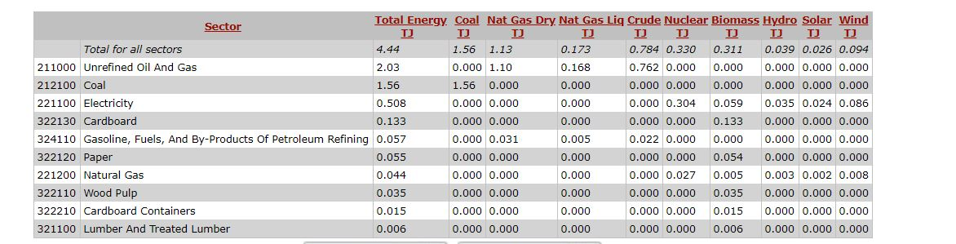

Table 10. China Energy Needed to Produce